Final Project Report
Project Title: Heritage Treasures: An In-Depth Analysis of UNESCO World Heritage Sites in Tableau

Submitted by: JETTIGUNDLA GOVARDHAN REDDY
Date: JULY 2026

1. Introduction
UNESCO World Heritage Sites represent cultural and natural treasures of outstanding value to humanity. With growing global interest in sustainable tourism and cultural preservation, analyzing these sites through data visualization provides valuable insights. This project leverages Tableau to create an interactive dashboard that explores various attributes of UNESCO World Heritage Sites worldwide.

2. Objective
- To explore and visualize global UNESCO World Heritage Sites.
- To analyze site distribution by continent, country, and category.
- To highlight endangered sites and temporal trends.
- To allow interactive exploration through filters and maps.

3. Dataset Description
• Source: UNESCO World Heritage Centre Open Data

• Format: CSV
• Key Columns:
- Name of Site o Country
- Region (Continent) o Category (Cultural, Natural, Mixed) o Year of Inscription o Endangered Status o Latitude & Longitude o Description

4. Tools & Technologies
Component | Description | Technology Used
Data Preprocessing | Data cleaning, removal of nulls & formatting | Tableau Prep Builder, MS Excel
Interactive Dashboard | Data visualizations, filters, maps, actions | Tableau Desktop
Frontend/Presentation | Web-based sharing and interactivity | Tableau Public

5. Methodology

a. Data Preparation
- Removed redundant or incomplete records
- Cleaned missing coordinates for geospatial mapping
- Grouped by year, category, and region for trend analysis

b. Dashboard Design
- Used multiple sheets to build a user-friendly dashboard
- Integrated filters for Category, Country, Year, and Endangered status
- Included tooltips, legends, and titles for clarity

6. Visualizations Created 1. World Map View
- Displays all UNESCO sites on an interactive map
- Colored by Category
- Tooltip shows Site Name, Country, and Year

2. Bar Chart - Sites by Country
- Top 10 countries with the highest number of sites
- Interactive filter applied based on Region

3. Category Distribution (Pie Chart)
- Percentage of Cultural, Natural, and Mixed sites
- Clickable segments filter other sheets

4. Sites Over Time (Line Chart)
- Shows number of new inscriptions each year
- Trend highlights growth in site recognitions

5. Endangered Sites Table
- List of currently endangered sites
- Includes Country, Category, and Year of Inscription

7. Key Findings
- Italy and China have the highest number of World Heritage Sites.
- Cultural sites dominate globally (~77%).
- A steady rise in inscriptions occurred post-1980s.
- Africa has fewer sites but a higher proportion of endangered ones.
- A small but significant number of Mixed sites exist, primarily in Asia-Pacific.

8. User Interactions in Dashboard
- Filters for Country, Category, and Year
- Map click filters to display associated site details
- Hover tooltips provide micro-level insights
- Dynamic interlinking across visualizations

9. Challenges Faced
- Incomplete coordinate data made mapping slightly tricky.
- Balancing visual clarity with data density.
- Ensuring Tableau Public compatibility for publishing.

10. Conclusion
This project demonstrates how data visualization using Tableau can uncover deep insights into global cultural and natural heritage. By making the data accessible and interactive, users can engage with the heritage landscape meaningfully. The dashboard can serve researchers, students, and heritage tourism planners.

11. Future Scope
- Integrate visitor statistics and funding data for economic insights.
- Add time-lapse map animation for historical visualization.
- Expand with 360° media or external links for virtual tourism.

12. Screenshots of Dashboard
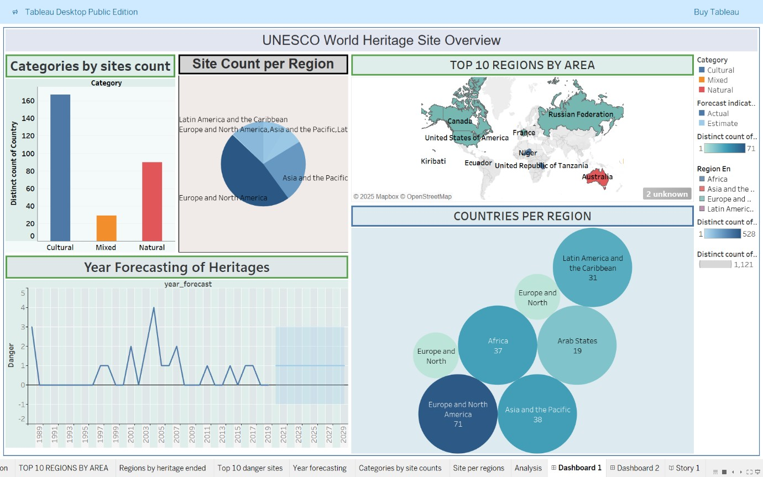

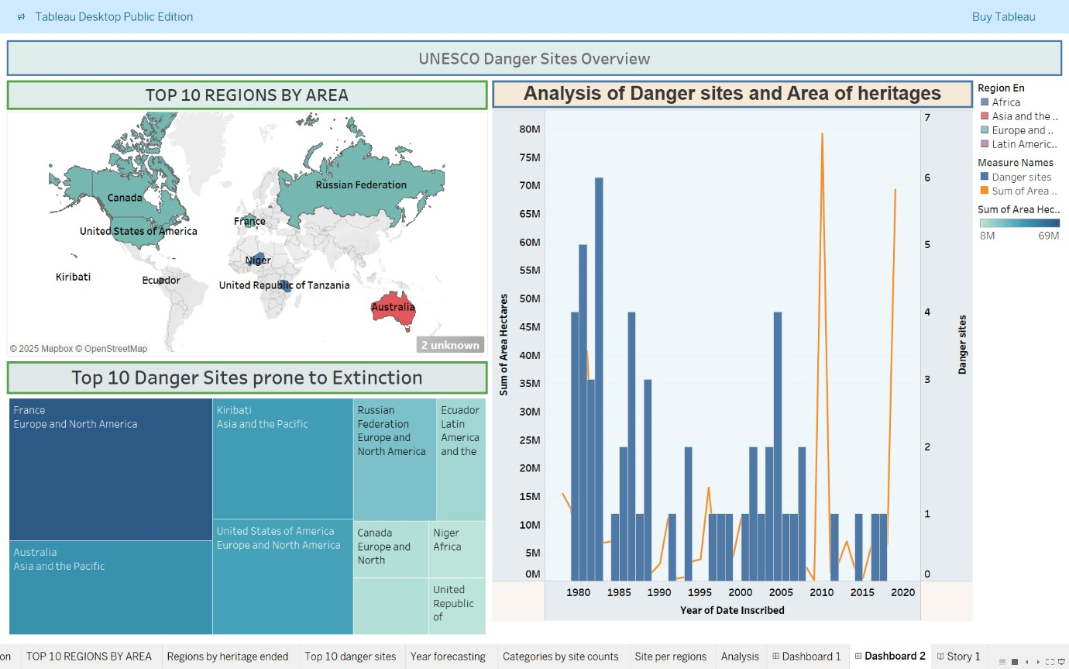
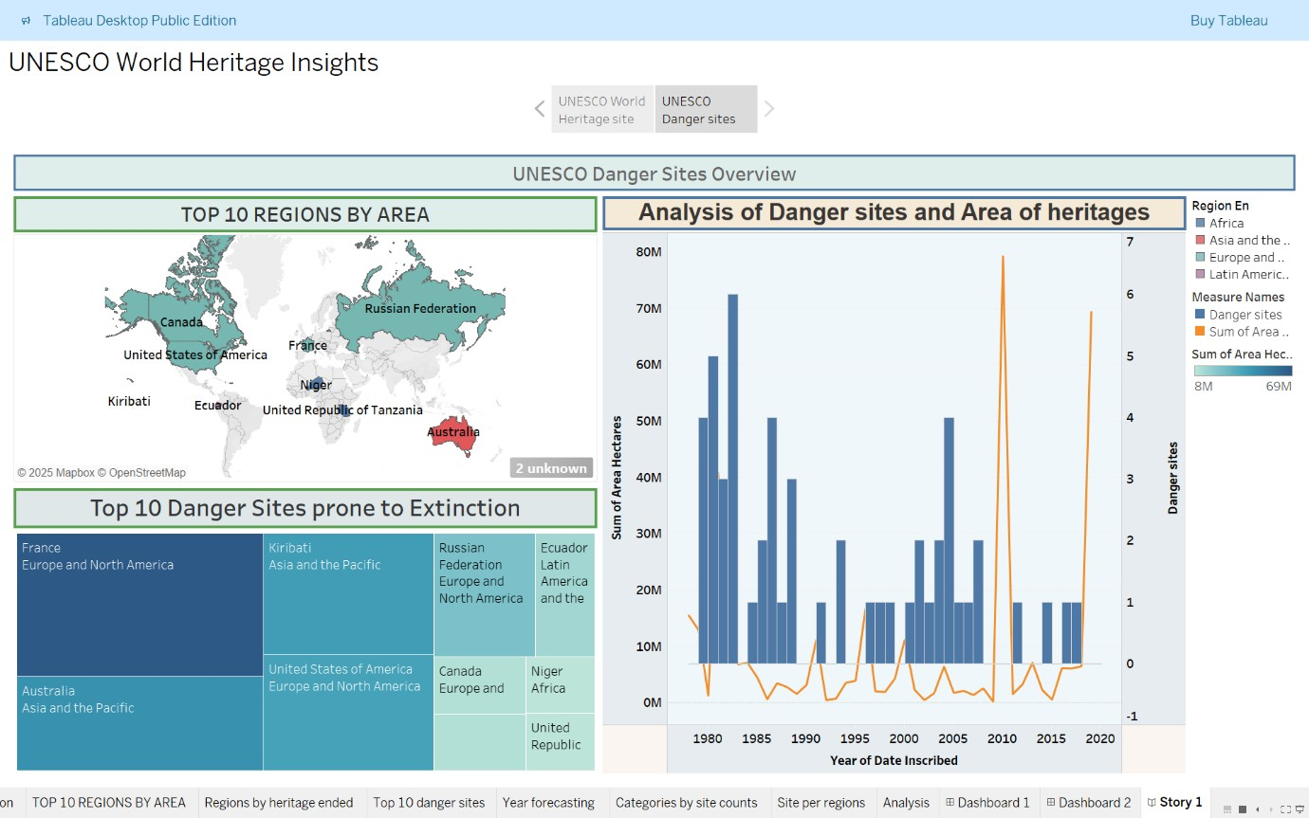

13. References
- UNESCO World Heritage Centre: https://whc.unesco.org/
- Tableau PubliC: https://public.tableau.com/app/profile/jettigundla.govardhan.reddy/viz/newunesco_17833612966560/Dashboard2?publish=yes
- Dataset Link: https://www.kaggle.com/datasets/ujwalkandi/unesco-world-heritagesites/data?select=whc-sites-2019.csv

